# App Themes & Scrollbar Colors

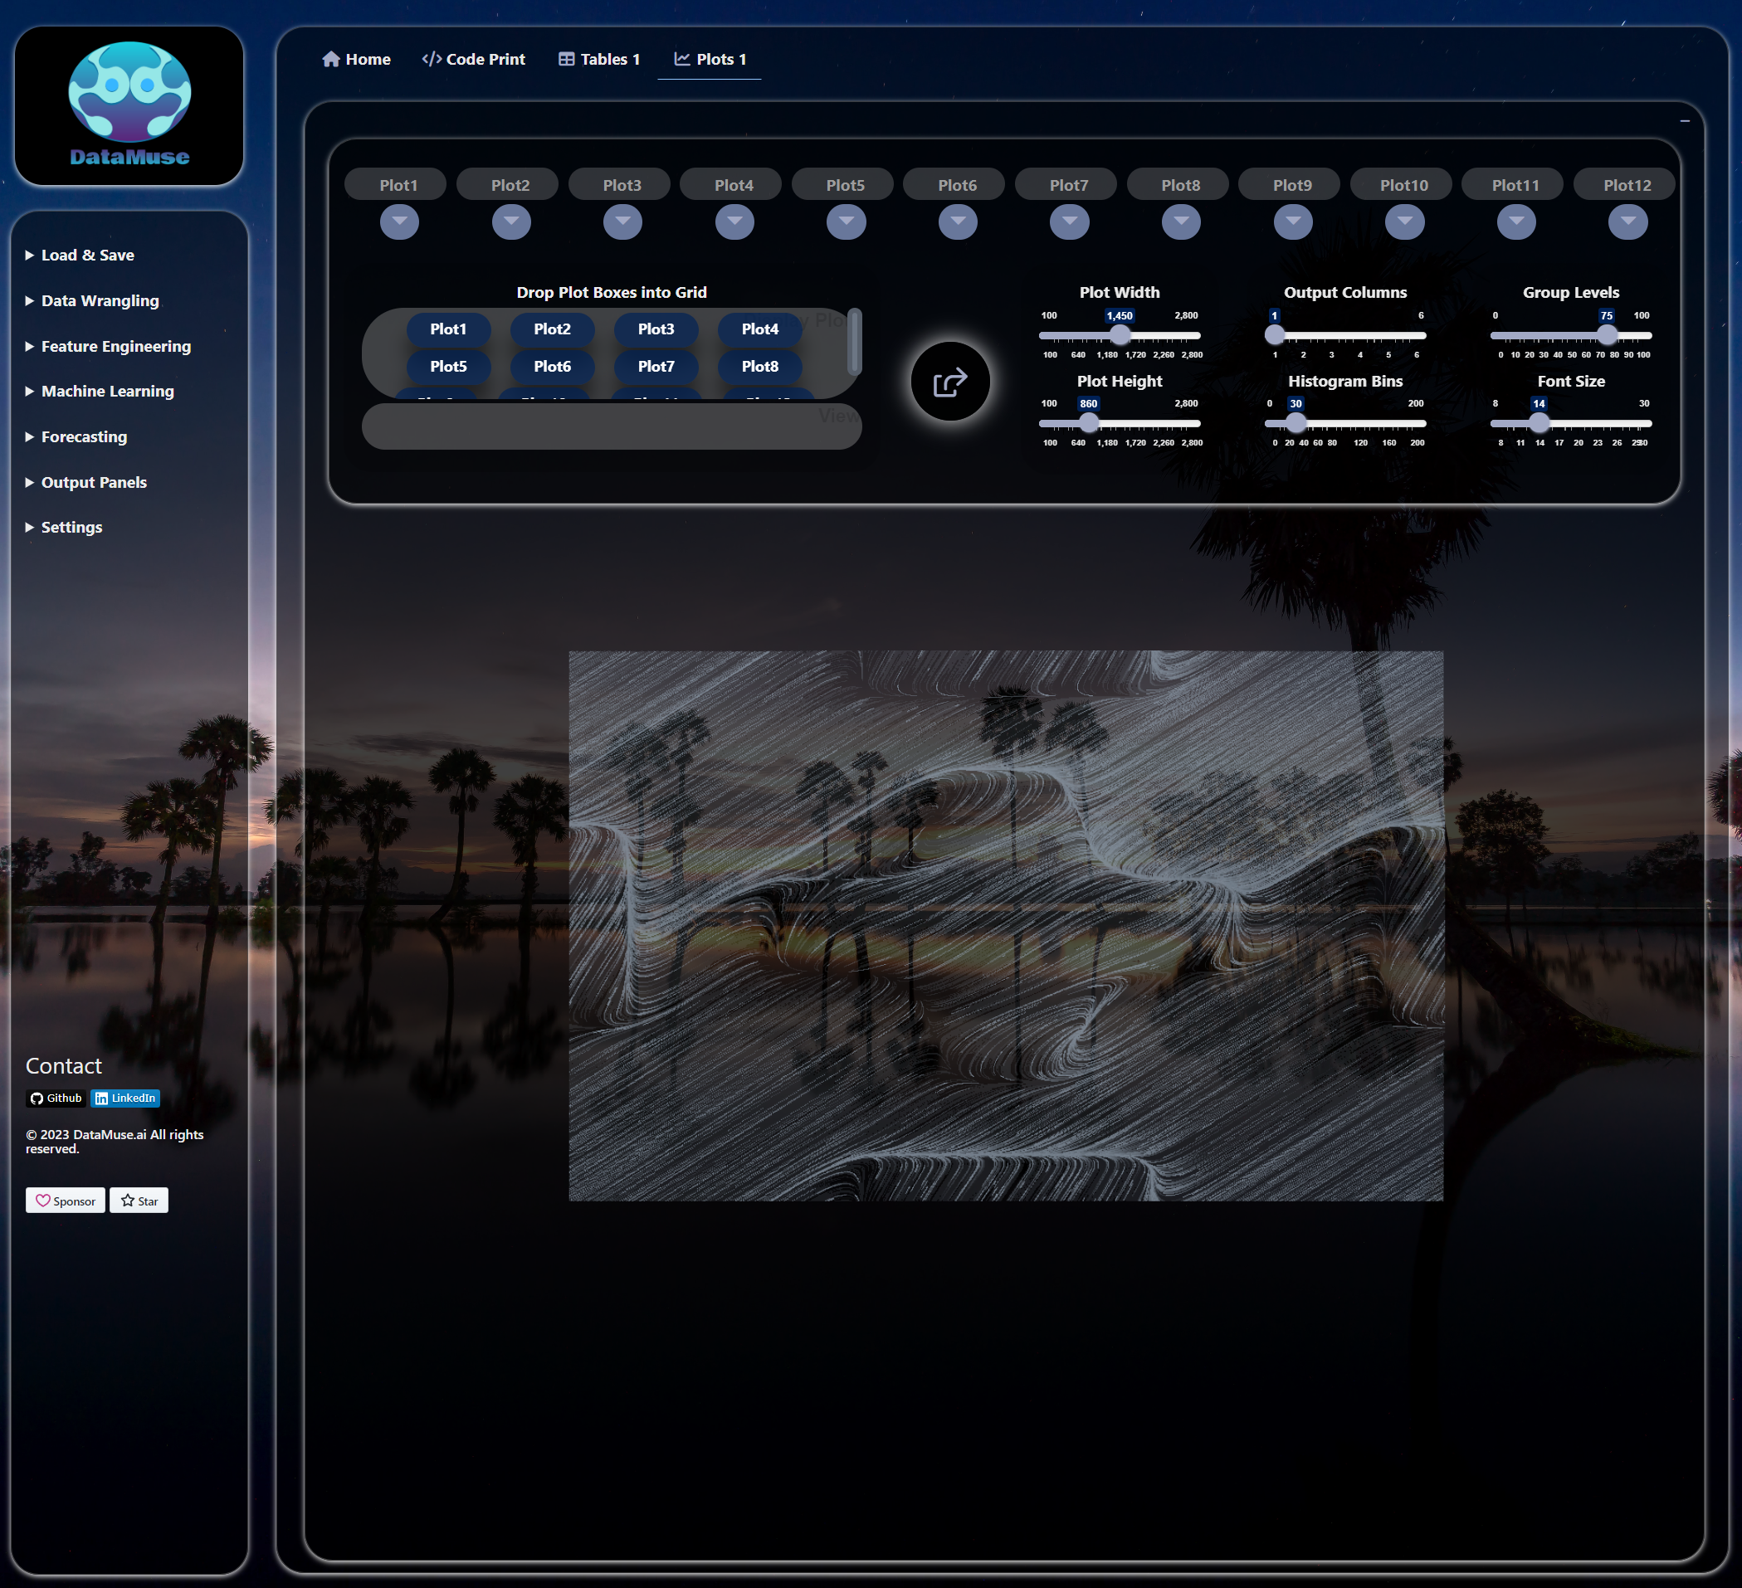

# Day-light-blue: #49d7f8

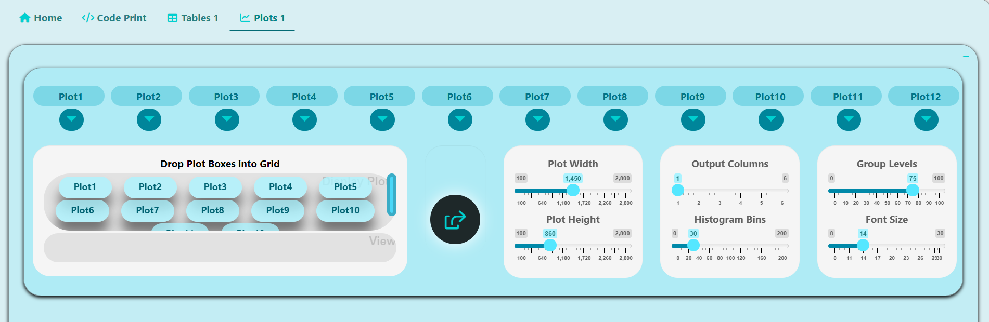

# Light -gray: #6c7684

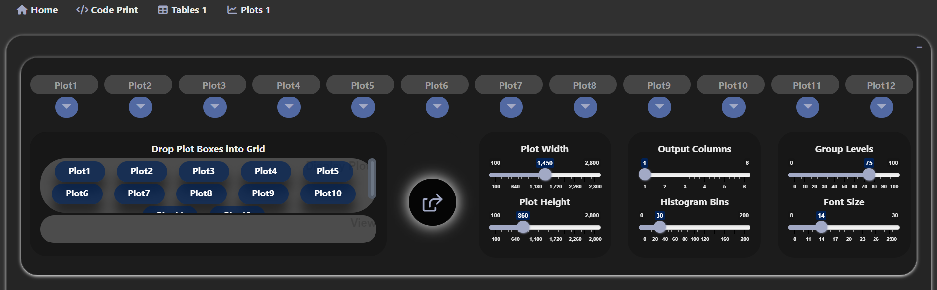

# Medium-gray (default selected): #6c7684

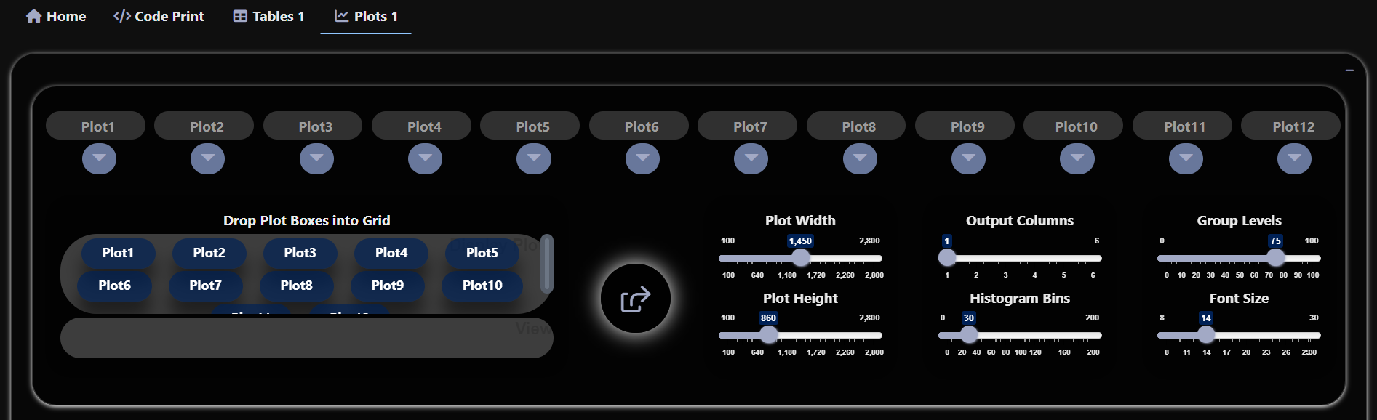

# Dark- gray: #6c7684

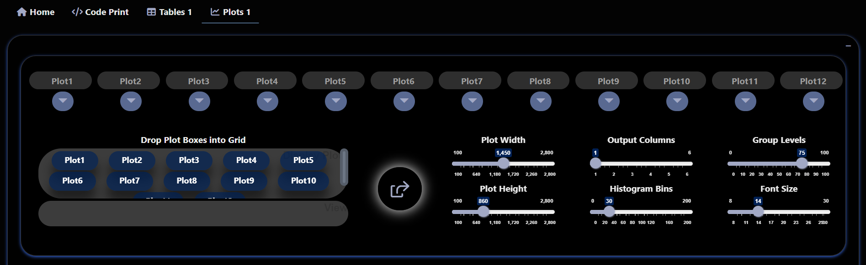

# Piano-black: #6c7684

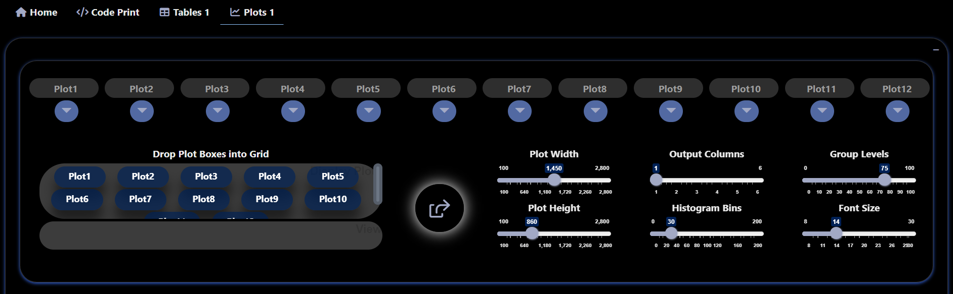

# Yellow: #888600

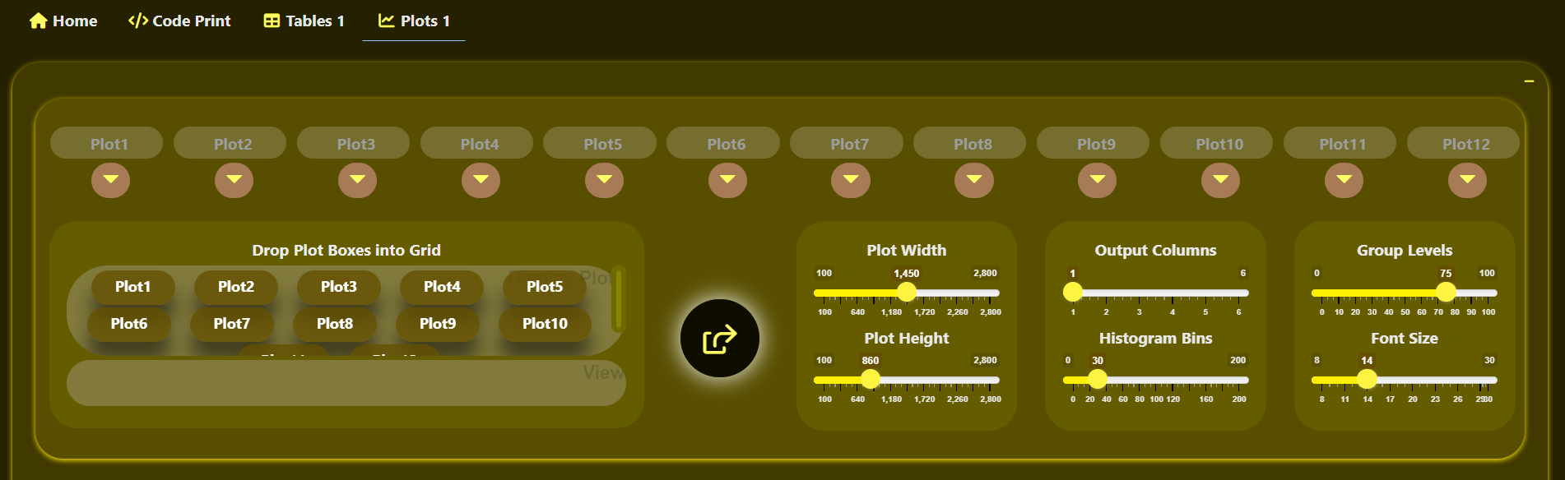

# Yellow-green: #648800

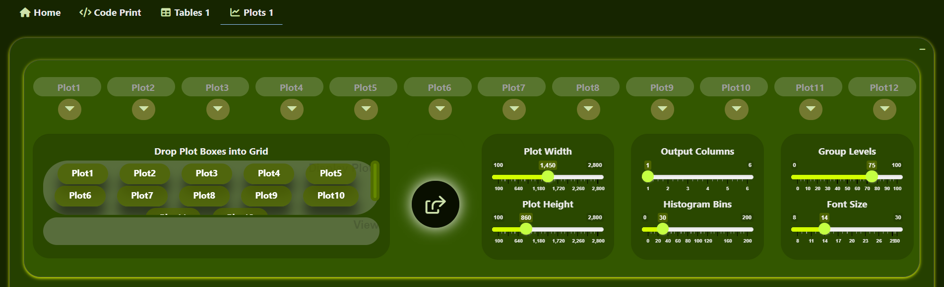

# Green: #0e7100

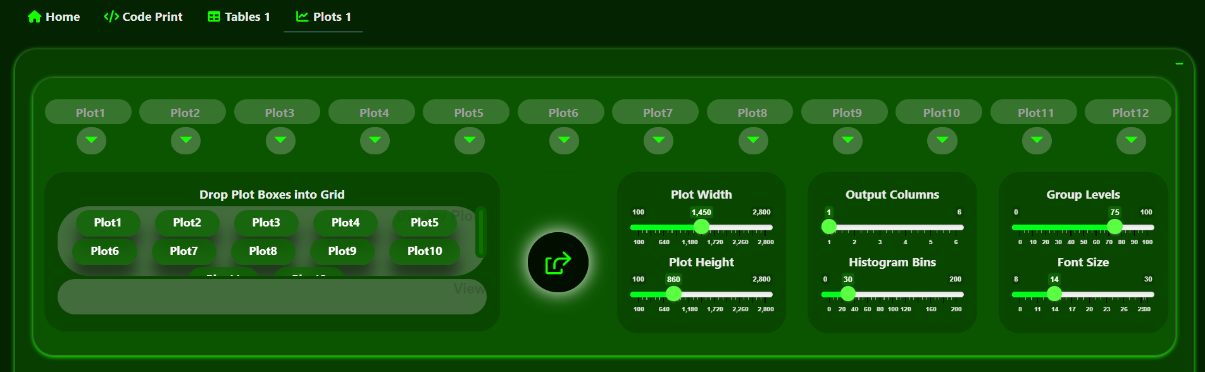

# Green-blue: #007141

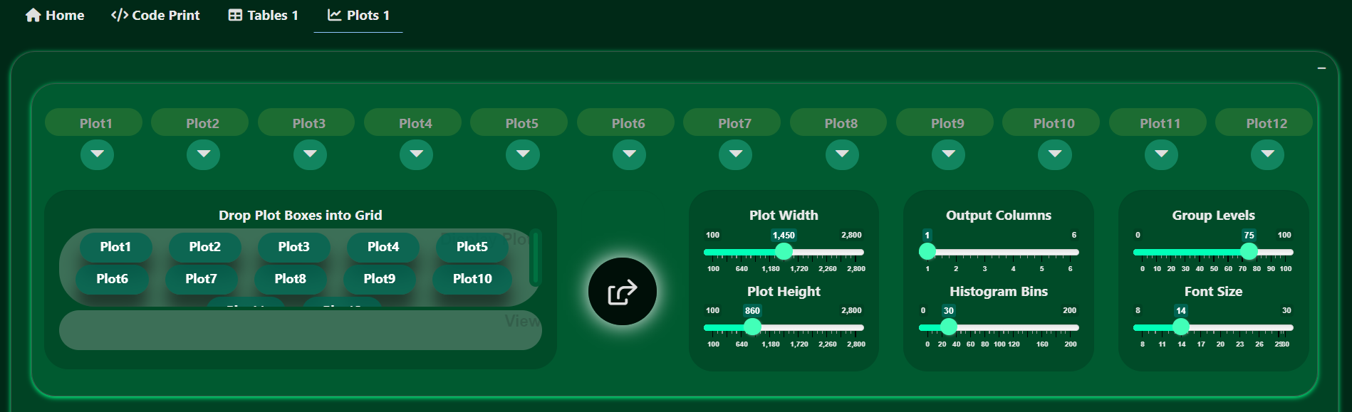

# Light-blue: #0078ae

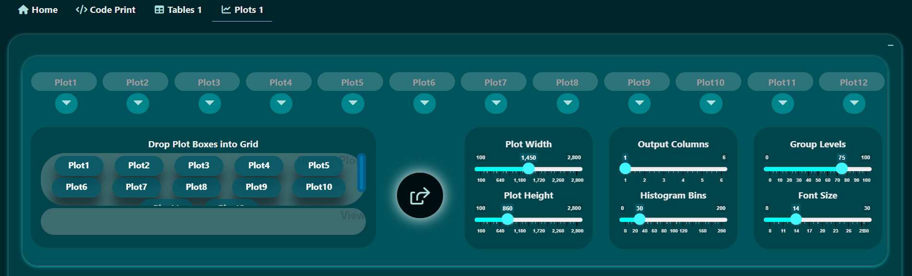

# Dodger-blue: #007bc3

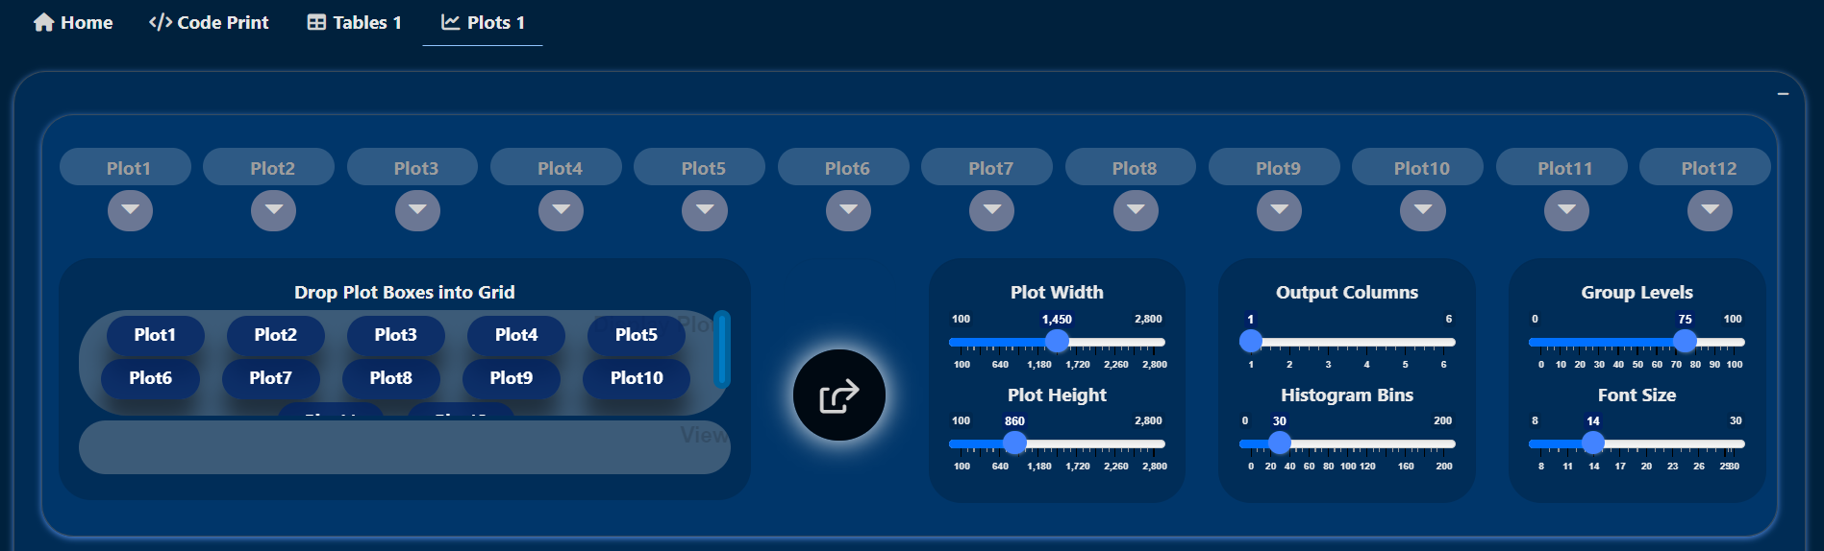

# Blue: #000271

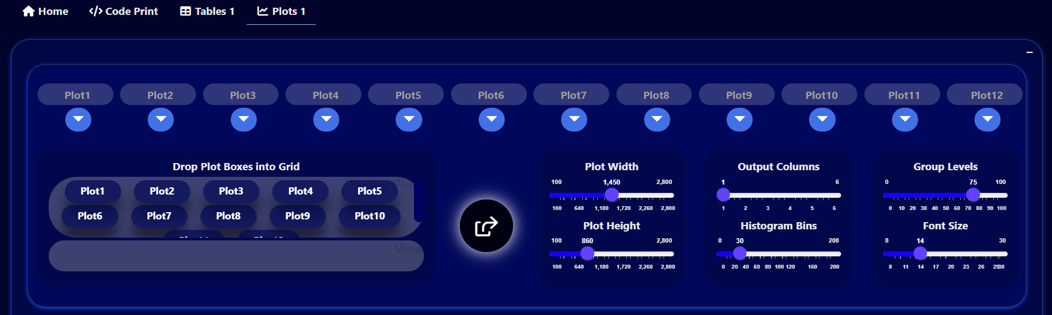

# Blue-purple: #390071

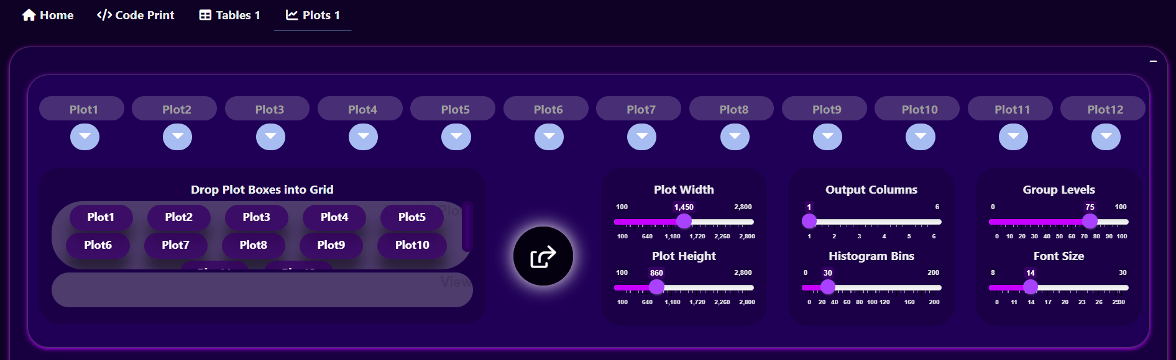

# Purple: #9a00b0

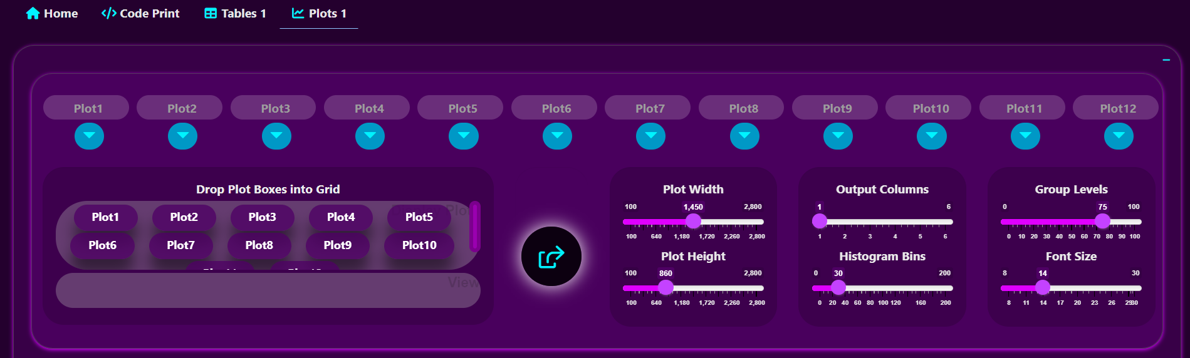

# Pink: #b0007c

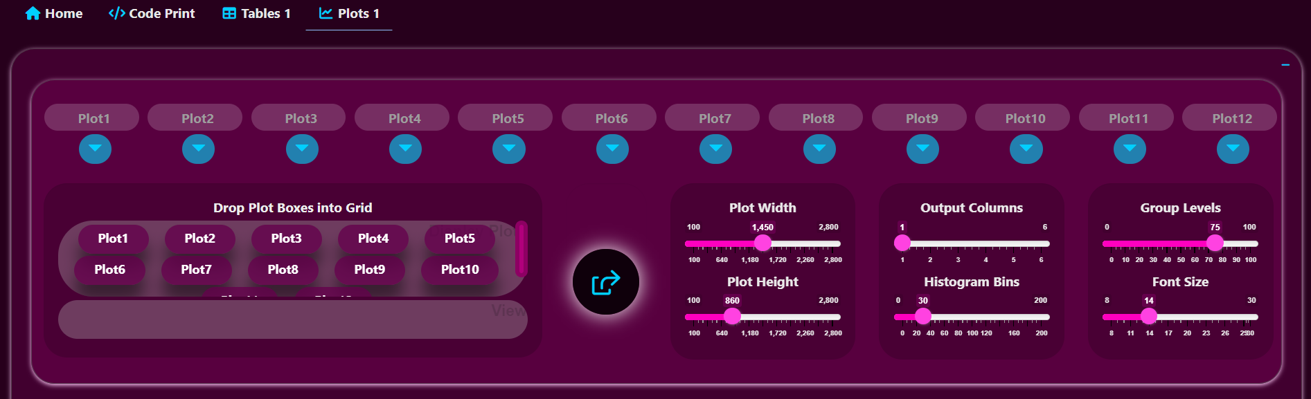

# Red: #800

